Procedure to update the SNF file
- Copy the attached file to the PecStar\Context\SNF folder.
- Start the PecConfig.
- Click on the site to check the Device Type. Update the PMC-630C SNF file as below:
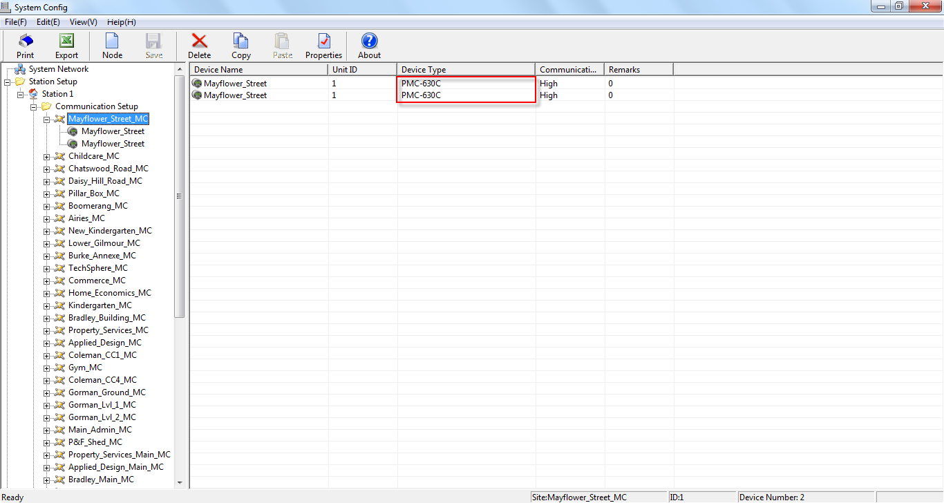
- Select the first device under the site, right-click on it and select Import SNF File from the pop-up menu.
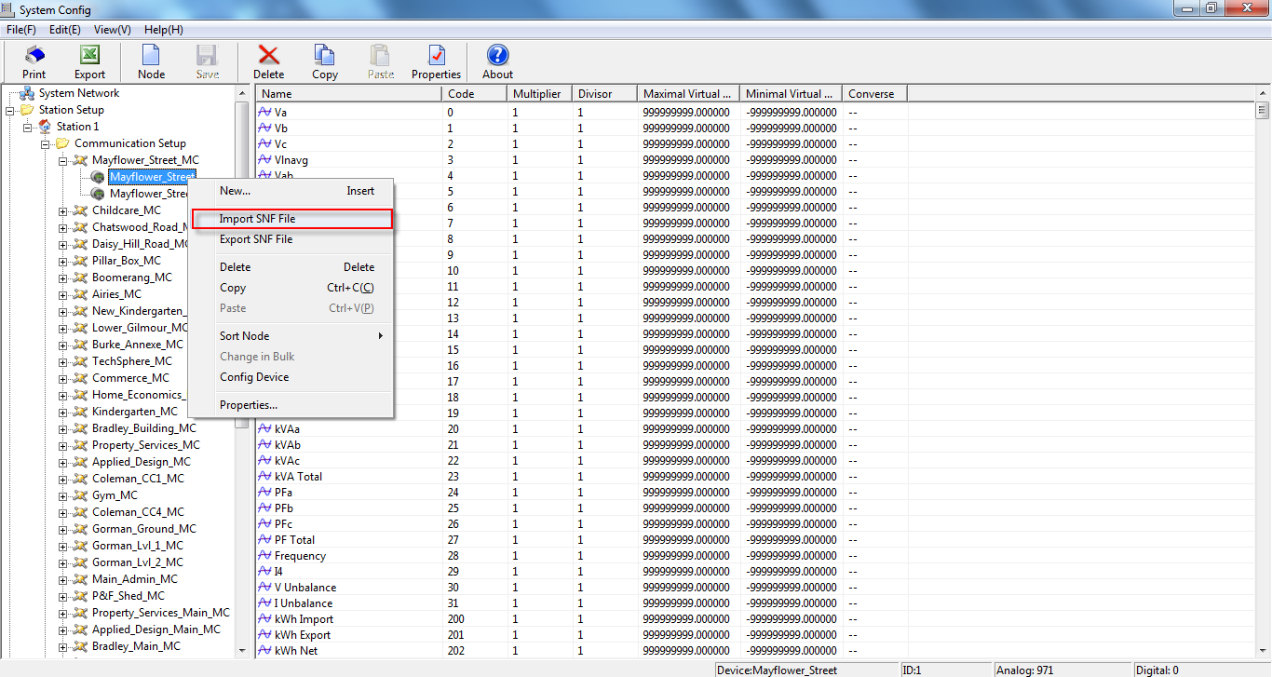

- Select the corresponding xxx-1 SNF file for the first device of the device type, and click Open.
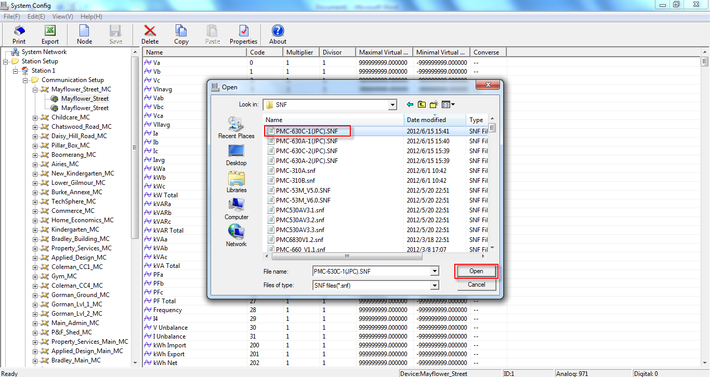
- The warning window appears. Select Yes to replace the same ID data.
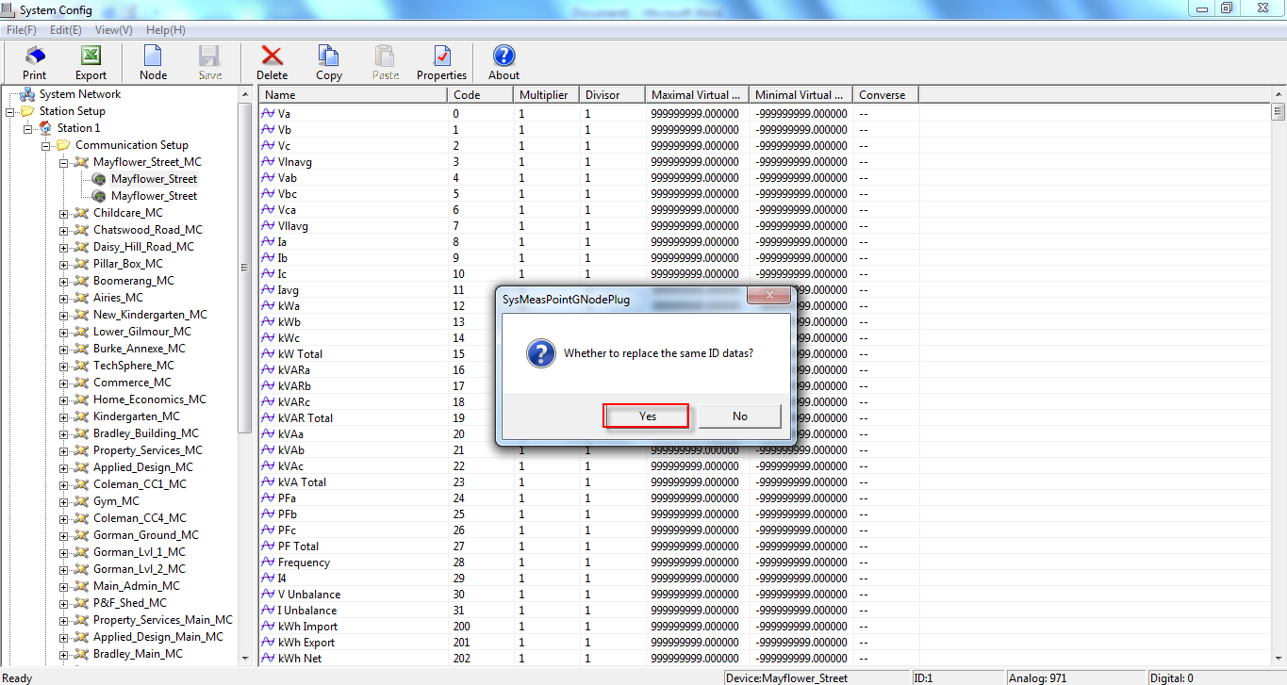

- Select the second device under the site, right-click on it and select Import SNF File from the pop-up menu.
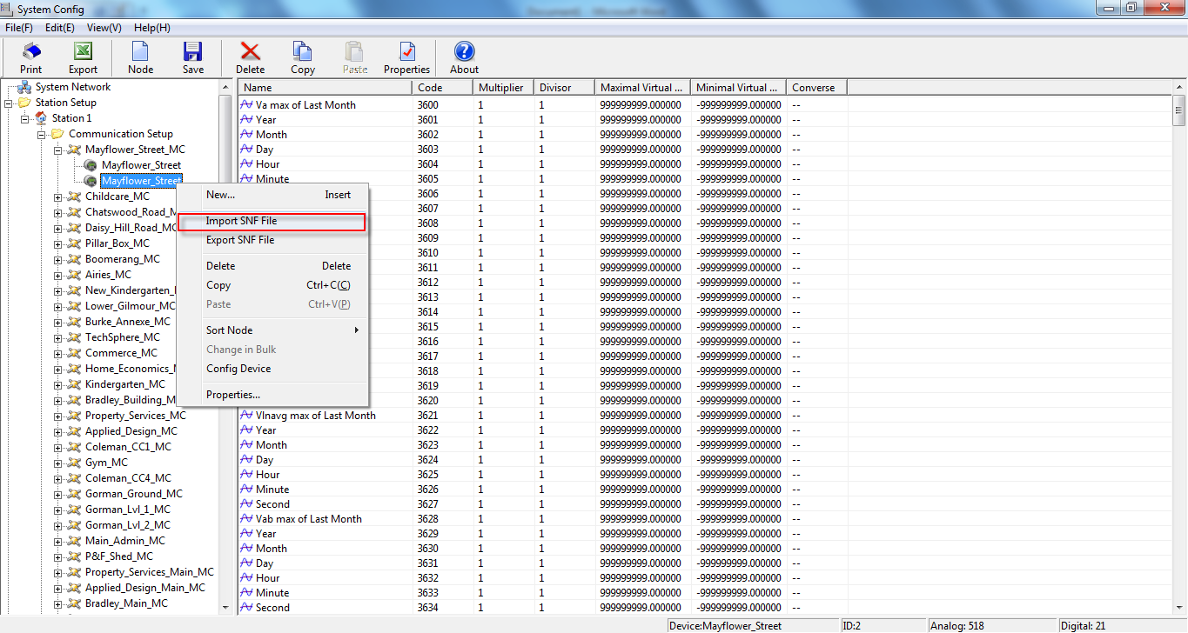
- Select the corresponding xxx-2 SNF file for the second device of the device type, and click Open.
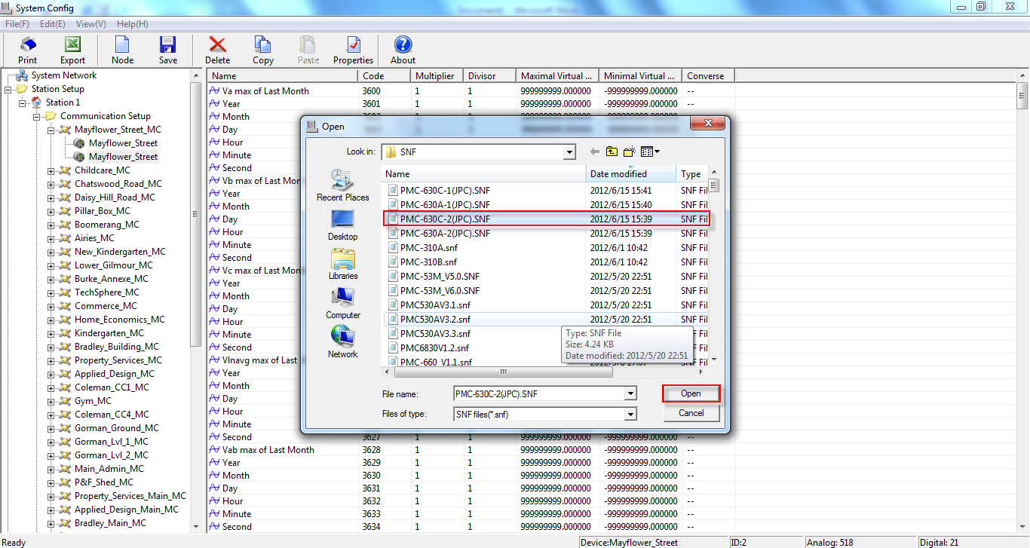

- The warning window appears. Select Yes to replace the same ID data.
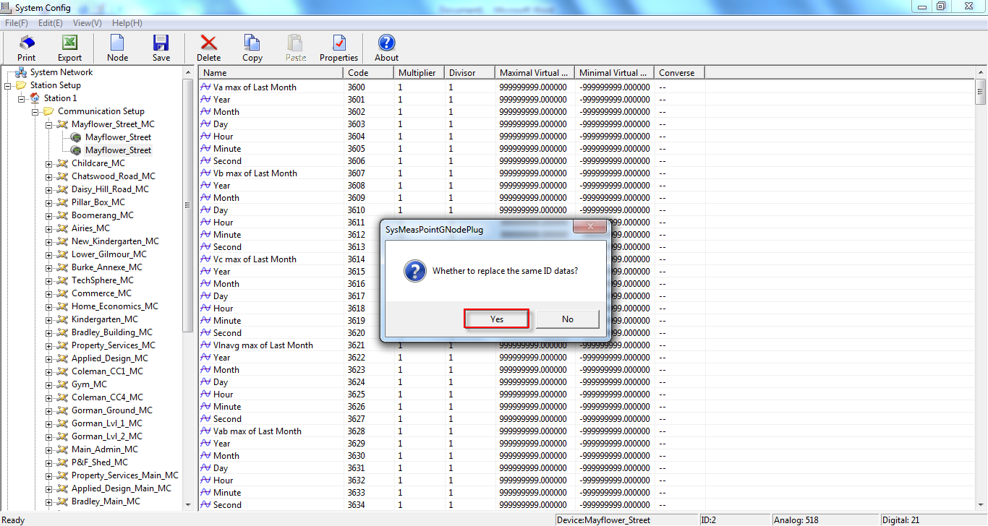
- Update the PMC-630A SNF file in the same way.
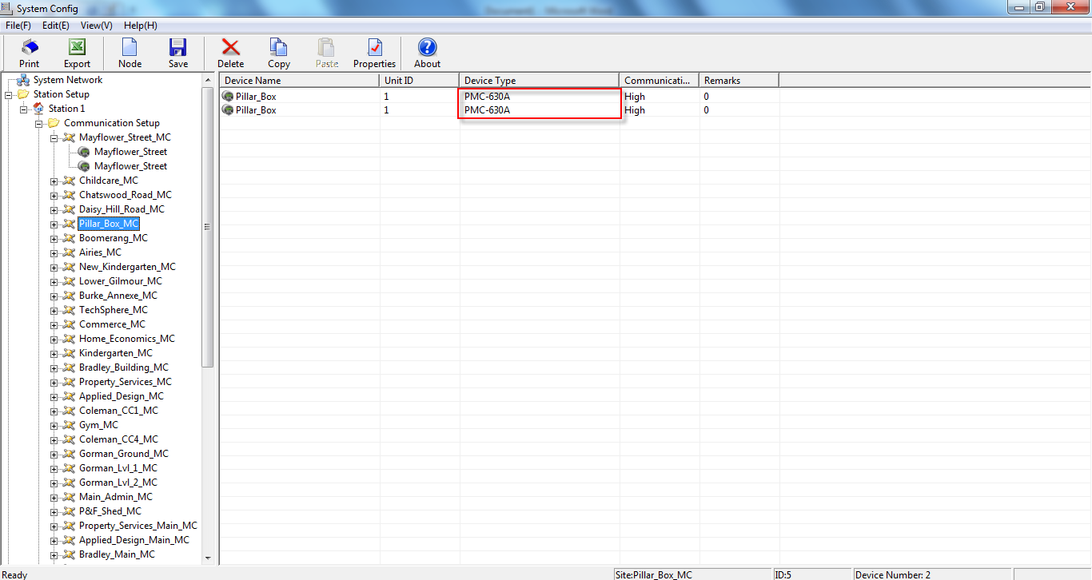

- After all the PMC-630A and PMC-630C devices are updated, save the changes to database.
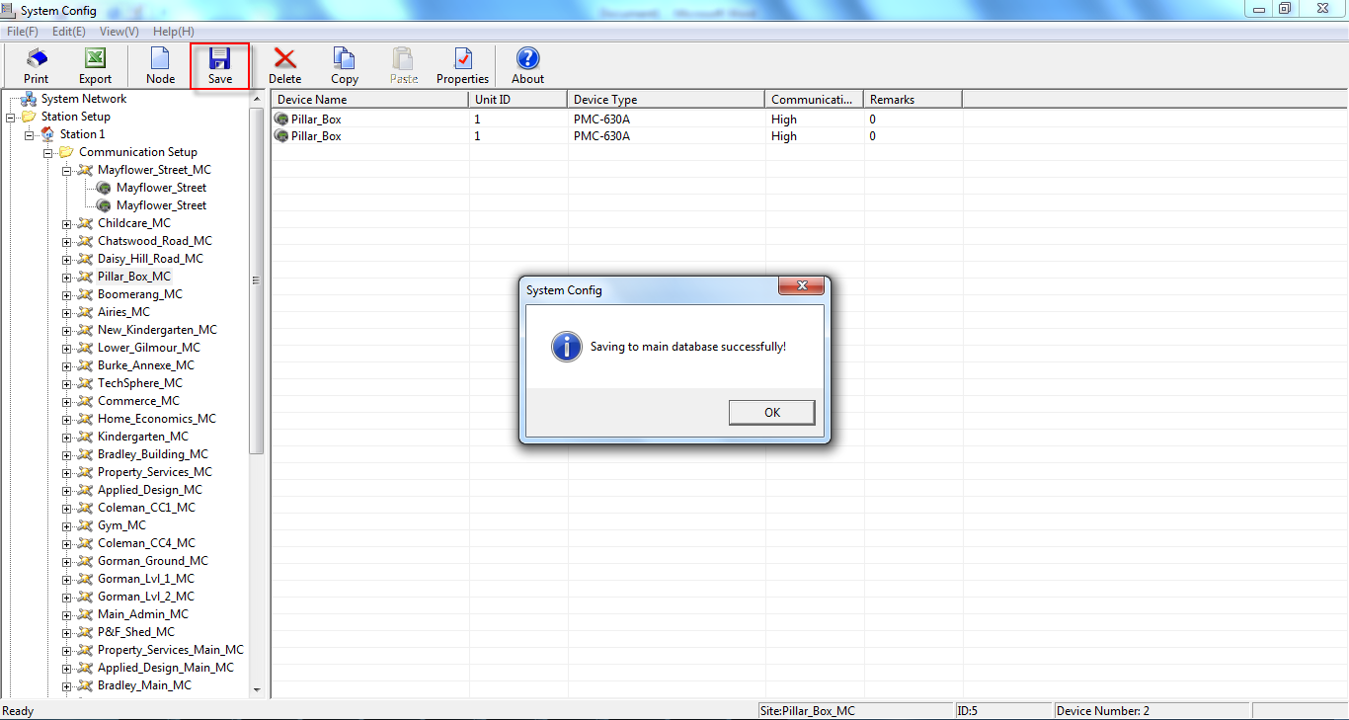
- Restart the PecSCADA.
